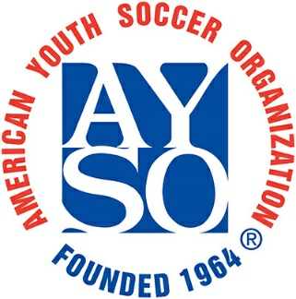

TEAM SPONSORSHIP FORM
Deadline- September 17th, 2019

Team Information
Please fill out completely before delivering to Sponsor

Team #: Team Name:

Coach: Division: Boys Girls

PERSON RESPONSIBLE FOR DELIVERING ACKNOWLEDGEMENTS (I.E. TEAM PLAQUE) TO SPONSOR(S):

Name:
SPONSOR INFORMATION

Sponsor Name:

Sponsor Contact Name:

Address: Street
City, State, Zip

Telephone:

Website:

We would like to donate:
- $200
- $150
- $100
- OTHER
Make Check Payable To: AYSO Region 206
Mail Check To: P.O. BOX 89324
Tucson, AZ. 85752

AYSO Region 206 is a 501c(3) Tax ID-95-6205398
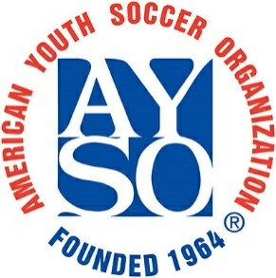

Dear Prospective Sponsor,
American Youth Soccer Organization (AYSO) is a non-profit organization founded in 1964 that promotes fitness, good sportsmanship, self-esteem, and team work in our youth between the ages of five and eighteen. By offering them a fun after-school and weekend activity, AYSO gives our youth a positive place to direct their boundless energy. The AYSO motto, “Everyone Plays” assures us that each child who is registered will play in EVERY GAME. Across the country, thousands of kids play AYSO Soccer. In Tucson, our Region 206 has over 800 players. While coaches and board members are unpaid volunteers; player registration fees do not cover all of our expenses. We work hard to keep our registration fees low so that more children can have the opportunity to play, and we rely on the generosity of local sponsors to help us make that a possibility.
We are requesting your involvement in this positive character building experience for the youth of our community. Your sponsorship will be acknowledged with:
- A team plaque to display to your community customers
- Region 206 website recognition
- A tax deduction (see your tax advisor for qualification)
- Free booth at our Soccer fest on October 26th, Mountain View Football Field
We hope you will join us by filling out the enclosed TEAM SPONSORSHIP FORM and return it to: AYSO REGION 206
Team Sponsor Coordinator
P.O. Box 89324
Tucson, Az. 85752
Please send the form and check prior to September 17th, so the sponsor recognitions (i.e. website recognition and plaques) can be ordered in a timely manner. If you have any questions, please contact me at 520-661-2487 or ae53thompson@gmail.com .
Thank You,
Ashley Thompson
Team Sponsor Coordinator AYSO Region 206

AYSO Region 206 is a 501c(3) Tax ID 95-6205398

